Climate Disagreement CoP Summary and Chat notes
10 September 2026

Dr Jane Robb referred to the following papers in her presentation:
- Alcoff, L. M. (2022). Extractivist epistemologies. Tapuya: Latin American Science, Technology and Society, 5(1). https://doi.org/10.1080/25729861.2022.2127231
- Robb J, Haggar J, Lamboll R, Castellanos E. Exploring the Value–Action Gap through Shared Values, Capabilities and Deforestation Behaviours in Guatemala. Environmental Conservation. 2019;46(3):226-233. doi:10.1017/S0376892919000067

Note that there is not open access to the second paper. I have copied one of the images shared below.

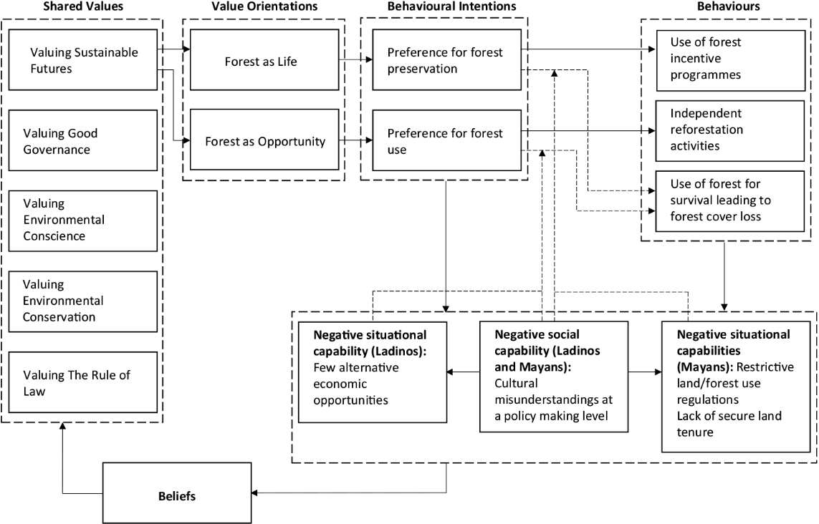
Fig 3. The results of the study applied to the Behaviour–Capabilities–Drivers model, showing land user shared values, value orientations, (negative) capabilities and links to behaviours.

Jane posed these questions for the group:
- How do we experience disagreement across our different parts?
- How can we welcome and sit with disagreement together as an anti-extractivist epistemological exercise?

Other reflections:
- How do we create space for disagreement?
- We need liminal spaces, to suspend our own positionality, which requires curiosity and challenge
- We need structures for disagreement, to be in conflict
- Let go of solutions and focus on needs
- ‘Hold tight to your needs and light to you strategies’
- How do we resource ourselves and our spaces?
- Acknowledgement doesn’t require agreement
- Permission to be unclear
- A problem that has no solution is still a fact
- If we pretend that we don’t have positionality then we can cause real harm

Chat notes and links

Vera: Designs for the Pluriverse – Wikipedia https://en.wikipedia.org/wiki/Designs_for_the_Pluriverse

Nancy: https://link.springer.com/chapter/10.1007/978-3-031-52973-3_9 provides an alternative conceptualisation informed by African Participatory music making… The whole book is on Creative Ruptions
Jane: Does it even necessarily mean that because someone is ‘a climate denier’ that climate change is not an issue for them? Especially as they care enough to ‘deny’ this position, rather than stay silent?
Love the idea of permission to be unclear, when these are such big issues we are working with and we are individuals as well as working within institutions
Tim: Apologies for having to drop out and not contributing but, as a business leader, this debate is long overdue. The manner by which a balance can been achieved between these issues and the powerful (but dangerous) cocktail of hubris, need to survive and animal spirits is a challenge which has too little airspace.
Ian: On the ‘suspending positionality’ point, what I meant to say was suspending any ‘negative’ impacts of our positionality …

